Dr. Song Kok Wee: Breaking Boundaries in Physics and Teaching
Published on February 20, 2025
Department of Physics
In Southeast Asia, there's a Malay saying: Bagai katak di bawah tempurung - like a frog under a coconut shell, believing its small world is all there is.
Song Kok Wee Kok Wee, Associate Professor of Physics at Xiamen University Malaysia, has spent his career looking beyond those limits. Over 20 years ago, he left Malaysia to study and work in Taiwan, the U.S., and the U.K. Now, in his forties, he has returned home to take on a new role in academia.
Song Kok Wee's interest in physics began in secondary school. He was fascinated by popular science books, especially those about advanced topics like relativity. This curiosity led him to study physics at National Tsing Hua University (NTHU) in Taiwan, a well-regarded institution with a strong academic reputation.
"NTHU had great professors and a competitive environment, but I realized that staying in one place too long could limit my perspective," Song Kok Wee says. To expand his experience, he moved to the University of Southern California (USC) for further studies.
Studying in the U.S. was an eye-opening experience. The research culture was different from Taiwan's, and he was exposed to new ways of thinking. At USC, he gradually shifted from studying fundamental physics to exploring more complex physical systems.
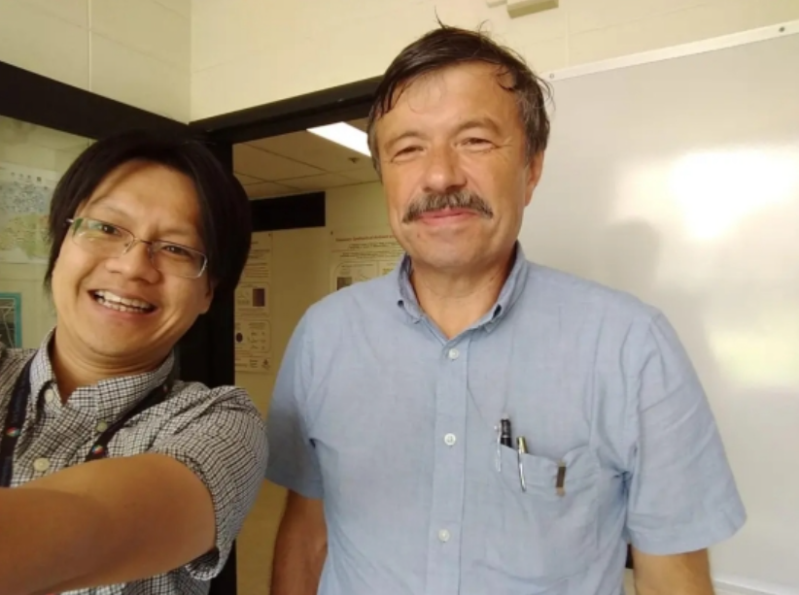

Song Kok Wee and his supervisor at Argonne National Laboratory
After earning his PhD, he continued his research at Argonne National Laboratory, focusing on two-dimensional (2D) materials. Later, he moved to the University of Manchester, home to the world's leading Graphene Research Institute, where graphene - the first 2D material - was discovered.
Song Kok Wee credits Nobel laureates Andre Geim and Konstantin Novoselov as key influences in his field. Even though graphene was discovered over a decade ago, research on 2D materials is still active, with new discoveries emerging regularly.
His research focuses on quantum many-body systems, quantum optics and polaritons, 2D materials, and material modeling, particularly how 2D materials interact with light. He actively participates in international conferences and has published in top journals like Physical Review Research, Physical Review B, and Light: Science & Applications. As a theoretical physicist, he works closely with experimental researchers worldwide.
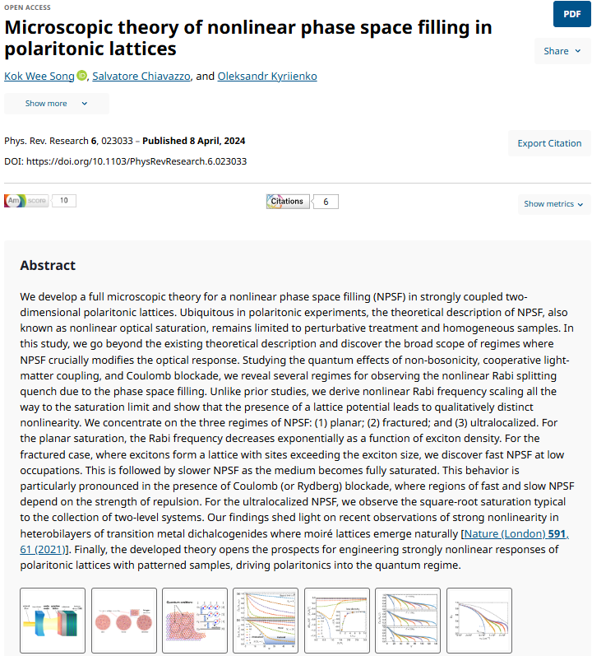
In September 2024, Song Kok Wee joined Xiamen University Malaysia as an Associate Professor, bringing years of research experience into the classroom.
Even with a strong research background, teaching was a new challenge. He spent a lot of time preparing lessons, grading assignments, and refining his teaching methods to help students understand complex topics.
Song Kok Wee's courses build on his research experience, but his main goal is to give students a solid foundation in physics. In introductory mechanics, he focuses on key principles and how they connect, helping students develop a structured way of thinking rather than just memorizing facts.
For higher-level courses, he uses a step-by-step approach. In thermodynamics and statistical physics, he emphasizes problem-solving. He also incorporates mathematical derivations to explain abstract concepts, linking equations to real-world applications.
"Physics can be tough," he admits, "but once students grasp the key ideas, they'll find it rewarding to solve complex problems."
Beyond the classroom, Song Kok Wee encourages students to go beyond textbooks, seeing physics as a way to uncover the mysteries of the natural world. "Interest is just the beginning. To go further, you need dedication and effort, he advises." He urges students to read widely, stay updated on the latest research, attend lectures, and participate in academic conferences.
For Song Kok Wee, teaching is more than passing on knowledge - it's about fostering a lifelong passion for science. He constantly reminds students, Don't be afraid to make mistakes. "Be bold in exploring your interests, conducting experiments, and seeking new discoveries."
Looking at his students at Xiamen University Malaysia, he admires their curiosity and confidence in expressing ideas. In them, he sees a new generation eager to explore the wonders of science.
To him, this is the essence of physics - pushing the boundaries of human understanding, one discovery at a time.

